Shantae Coote
2111789
Individual Assignment 2
CIT2011
Monday 3pm – 5pm
Tutor: C. Anuli
Date: November 21, 2025

Github Repo link: https://github.com/Shantae-C/Web-Programming-IA2.git
Intended colour palette
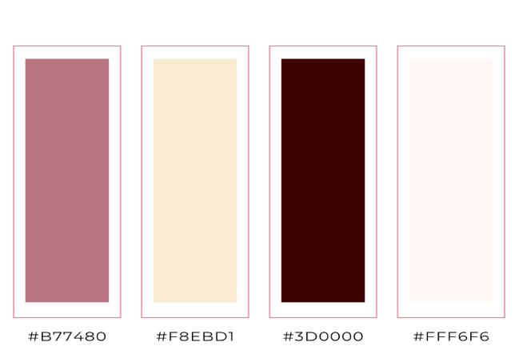
Business Logo


List of functions
- renderCart()
This function displays all cart items inside the <tbody id=”cartBody”>.
It also updates the cart table in real time.
- updateNavCartCount()
This function updates the number of items shown beside the cart link in the navigation bar.
- clearCart()
This function removes all the items from the local storage and refreshes the page by calling the renderCart() function.
- calculateSubtotal()
This function is responsible for calculating the total cost of products added before tax and returns a subtotal.
- calculateTax()
This function calculates the tax based of the subtotal.
- calculateDiscount()
This function calculates the discount.
- calculateTotal()
Updates the summary section.
- updateQuantity(productid, newQty)
This function updates the quantity of a specific item in the cart.
- removeItem(productId)
This function deletes one specific item from the cart.
- saveCart()
This function saves the updates from the cart into the local storage.
- loadCart()
This function reads the data from the local storage.

References
Build and Deploy Ecommerce Website With HTML CSS JavaScript | Full Responsive Ecommerce Course FREE. (n.d.). Www.youtube.com. Retrieved March 20, 2024, from https://www.youtube.com/watch?v=P8YuWEkTeuE&list=PL9bD98LkBR7P8MYh0RzNSHgeVNTA8g0nB&index=1
Everyone’s A Star! Exclusive Hot Pink Glitter Vinyl - 5 Seconds of Summer Official Store. (2025). 5 Seconds of Summer Official Store. https://5sos.com/products/everyone-s-a-star-exclusive-hot-pink-glitter-vinyl
“Fancy That” Blue Vinyl (D2C Exclusive). (2025). Warner Music Store. https://store.warnermusic.com/products/fancy-that-blue-vinyl-d2c-exclusive?srsltid=AfmBOoq7Ylmdfny_GYspjbnTqdkzJ89XhEpsxxQaIFOzidukEhoYkai2
GeeksforGeeks. (2023, October 18). Validate Email in JavaScript. GeeksforGeeks. https://www.geeksforgeeks.org/javascript/javascript-program-to-validate-an-email-address/
Lana Del Rey - Born To Die: Vinyl 2LP - Recordstore. (2025). Recordstore. https://recordstore.co.uk/products/born-to-die-vinyl-2lp?srsltid=AfmBOoqXOWiVZnIkjlGcr5RryoyRYZs8rB54BlZQC27pOzhYbeySIjCF
Sleeping With Sirens - “Complete Collapse” Orange + Electric Blue Butterfly w/ Black Splatter Vinyl. (2025). Sumerian Merch. https://sumerianrecords.com/products/sleeping-with-sirens-complete-collapse-orange-electric-blue-butterfly-w-black-splatter-vinyl?srsltid=AfmBOorOAduxEb-vLCmgGYo0icpiajcks0jxlqX3Pm7wSJDqQWmPJ7AZ
w3Schools. (2019). JavaScript Tutorial. W3schools. https://www.w3schools.com/js/default.asp

